19.7: a)

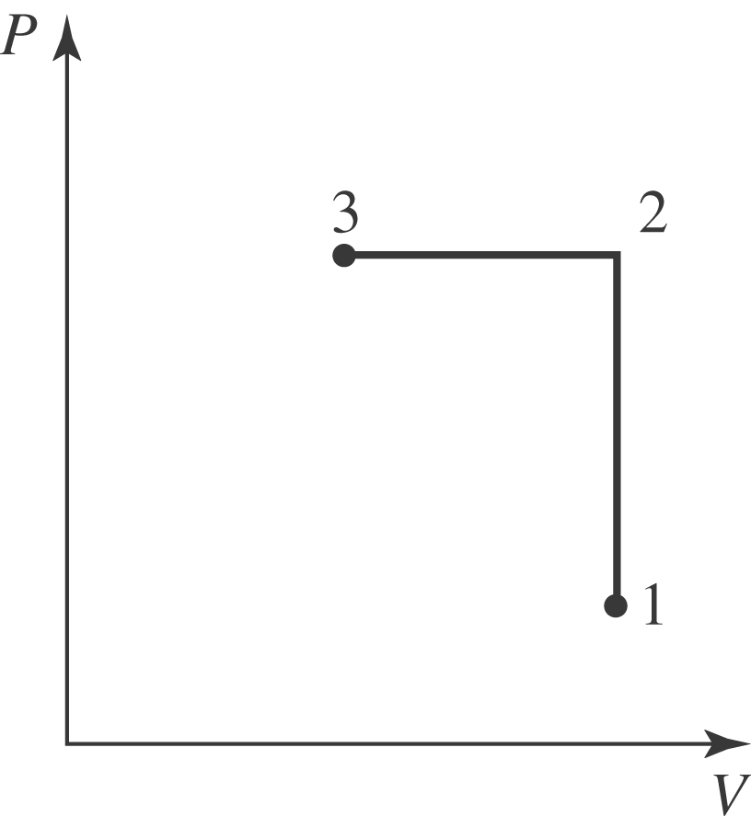
b) In the first process, 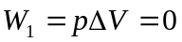. In the second process,

